HW09 SCD

DWBI

Shivam Verma

Create table command (source table):

CREATE TABLE [dbo].[employee](

[EmpID] [varchar](255) NOT NULL,

[First] [varchar](255) NULL,

[Last] [varchar](255) NULL,

[Rate] [varchar](255) NULL,

[Title] [varchar](255) NULL,

[ZipCode] [varchar](255) NULL

) ON [PRIMARY]

GO

Create table command (destination table):

CREATE TABLE [dbo].[Dim_employee](

[DimEmpID] int IDENTITY(1,1) NOT NULL,

[EmpID] int NULL,

[First] [varchar](255) NULL,

[Last] [varchar](255) NULL,

[Rate] [varchar](255) NULL,

[Title] [varchar](255) NULL,

[ZipCode] [varchar](255) NULL,

[Start Date] [date] NULL,

[End Date] [date] NULL,

[Update] [date] NULL,

[Prior Zip] [varchar](255) NULL

) ON [PRIMARY]

GO

Screenshot of Control Flow:

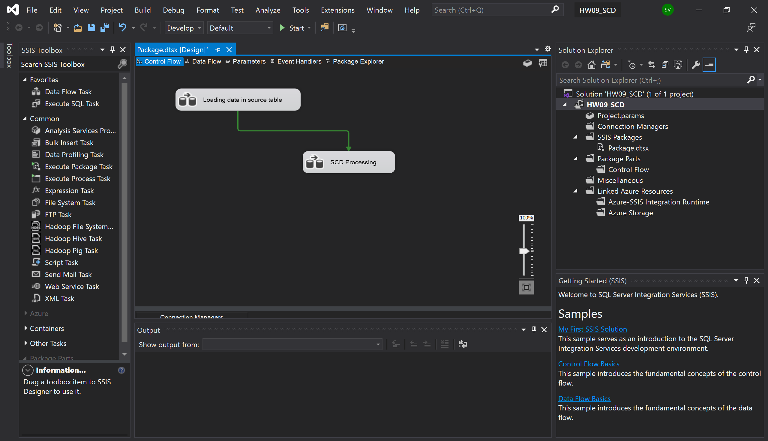

Screenshot of data flow to load data to source table from flat file:

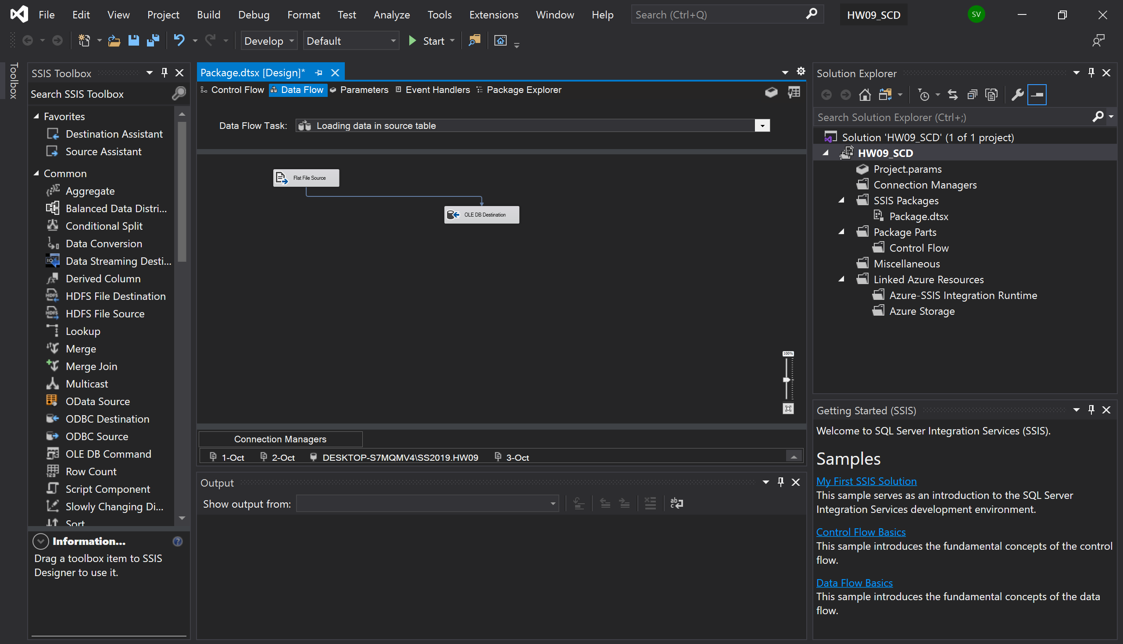

Screenshot to show data is loaded properly:

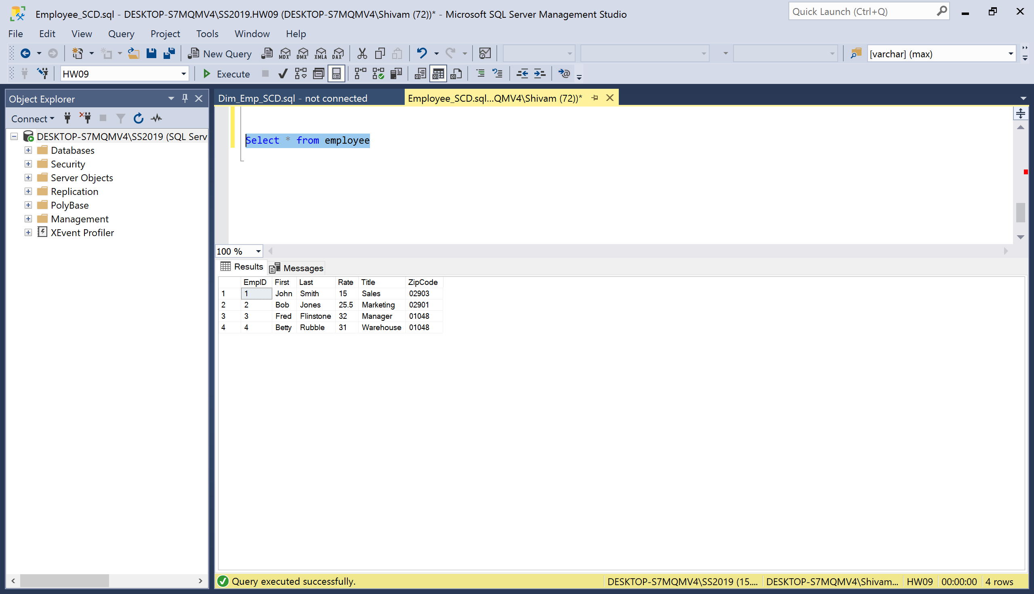

Screenshot of SCD processing data flow:

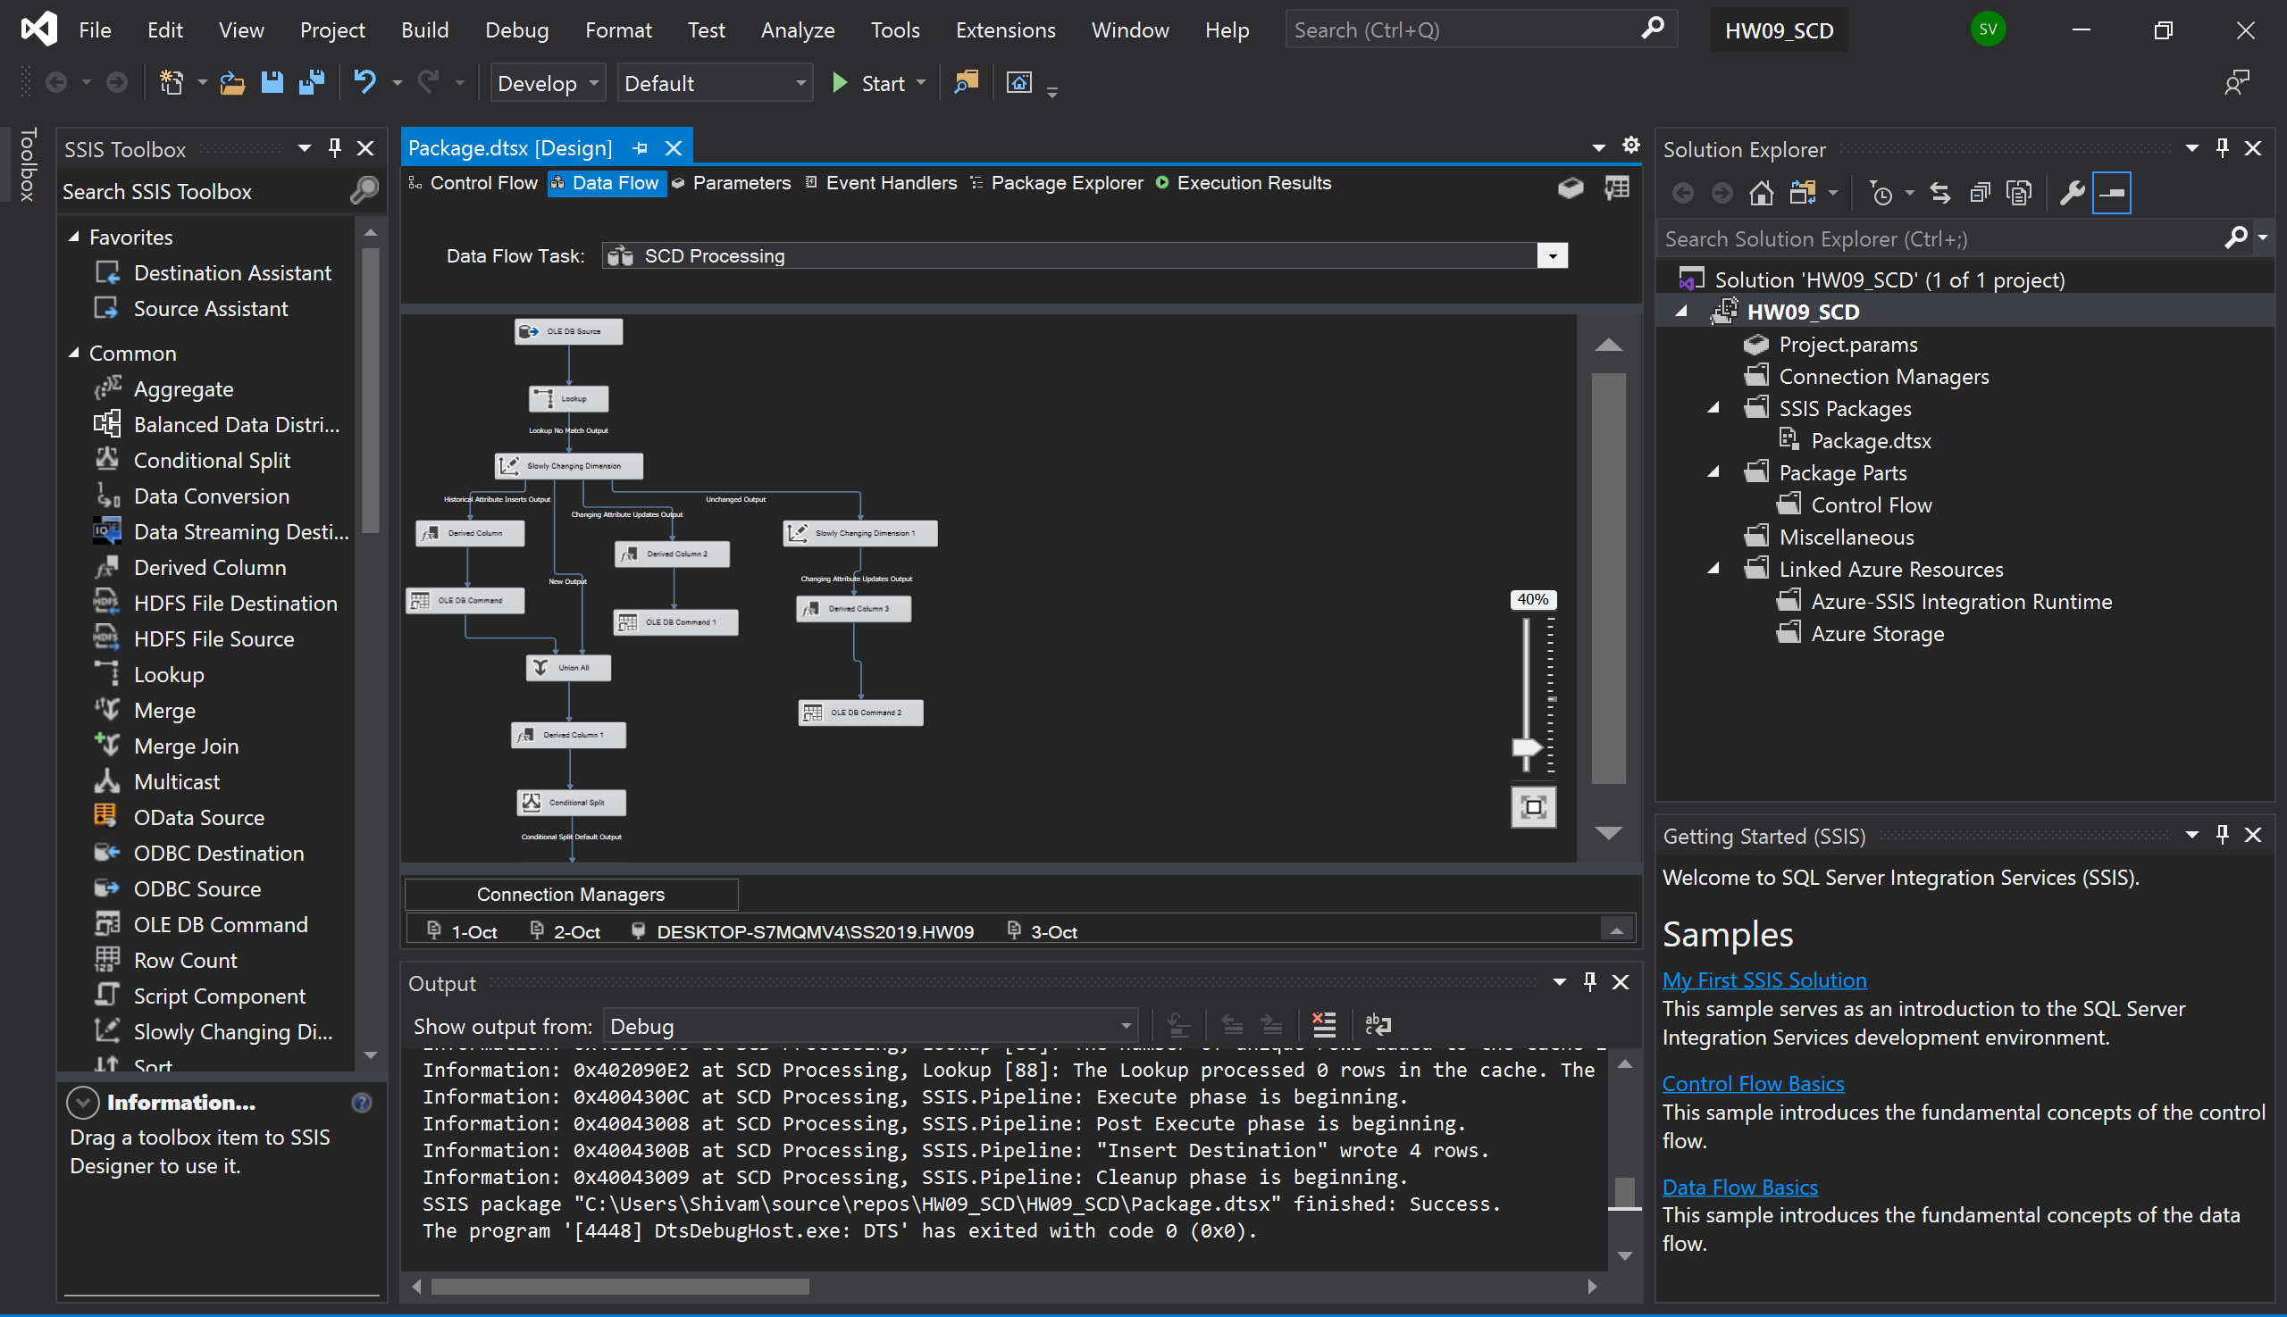

Cont.

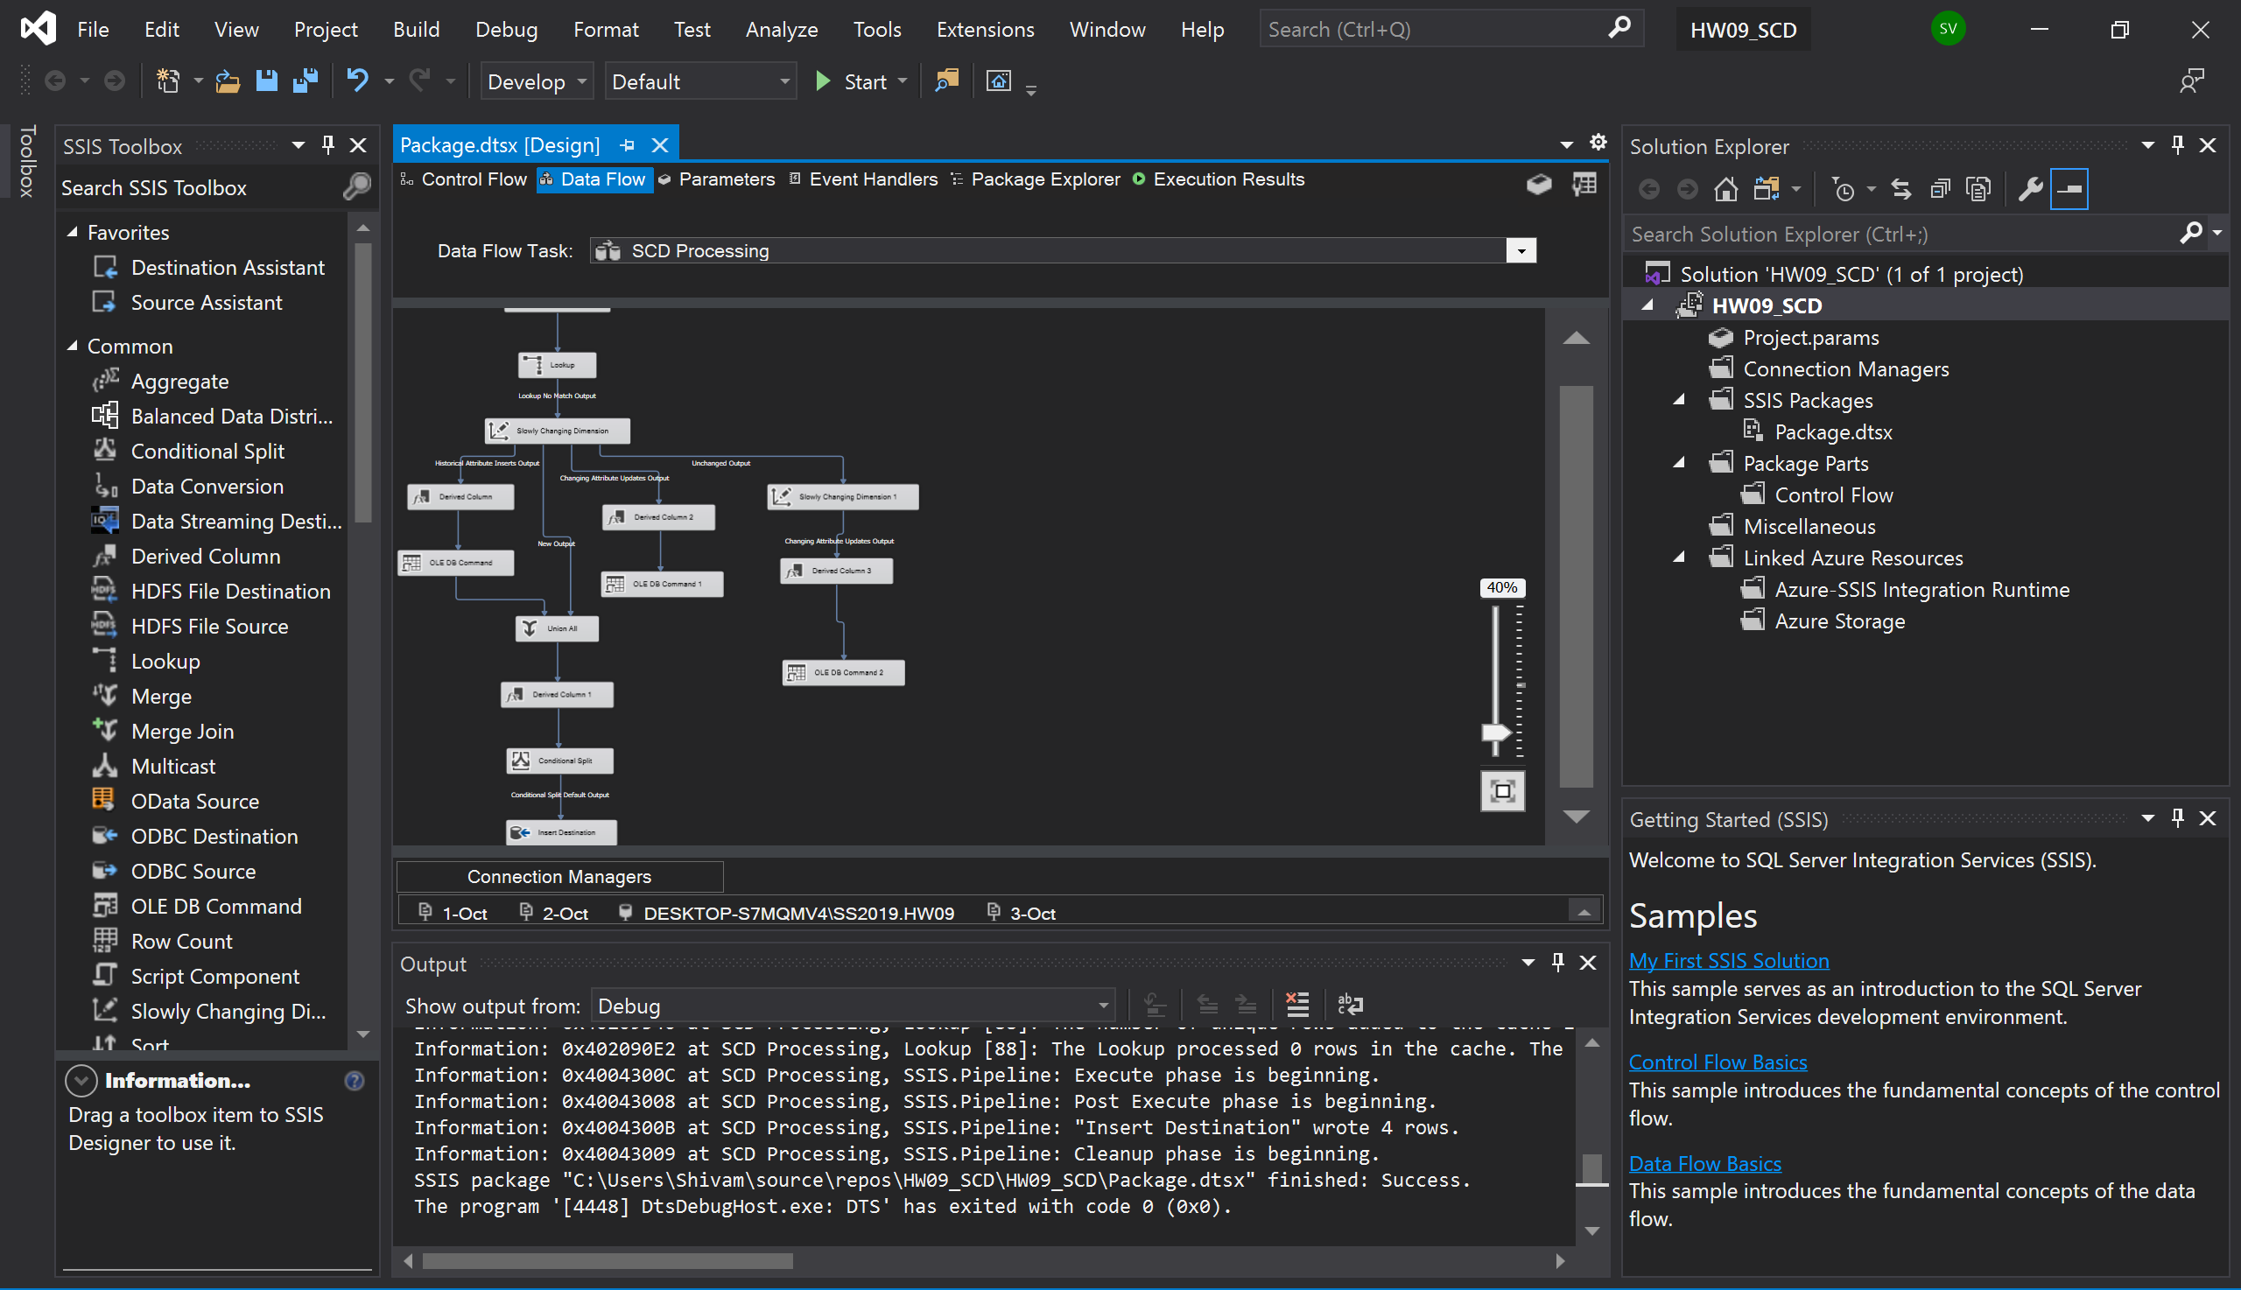

Screenshot to show package is working properly:

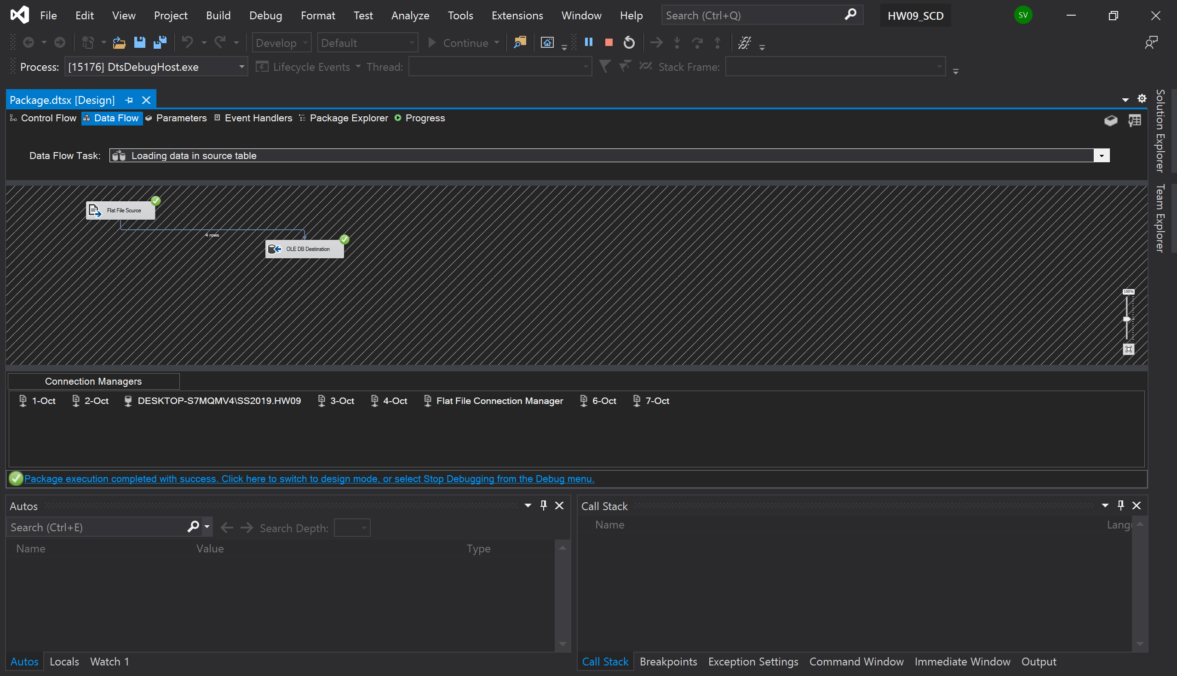

Cont.

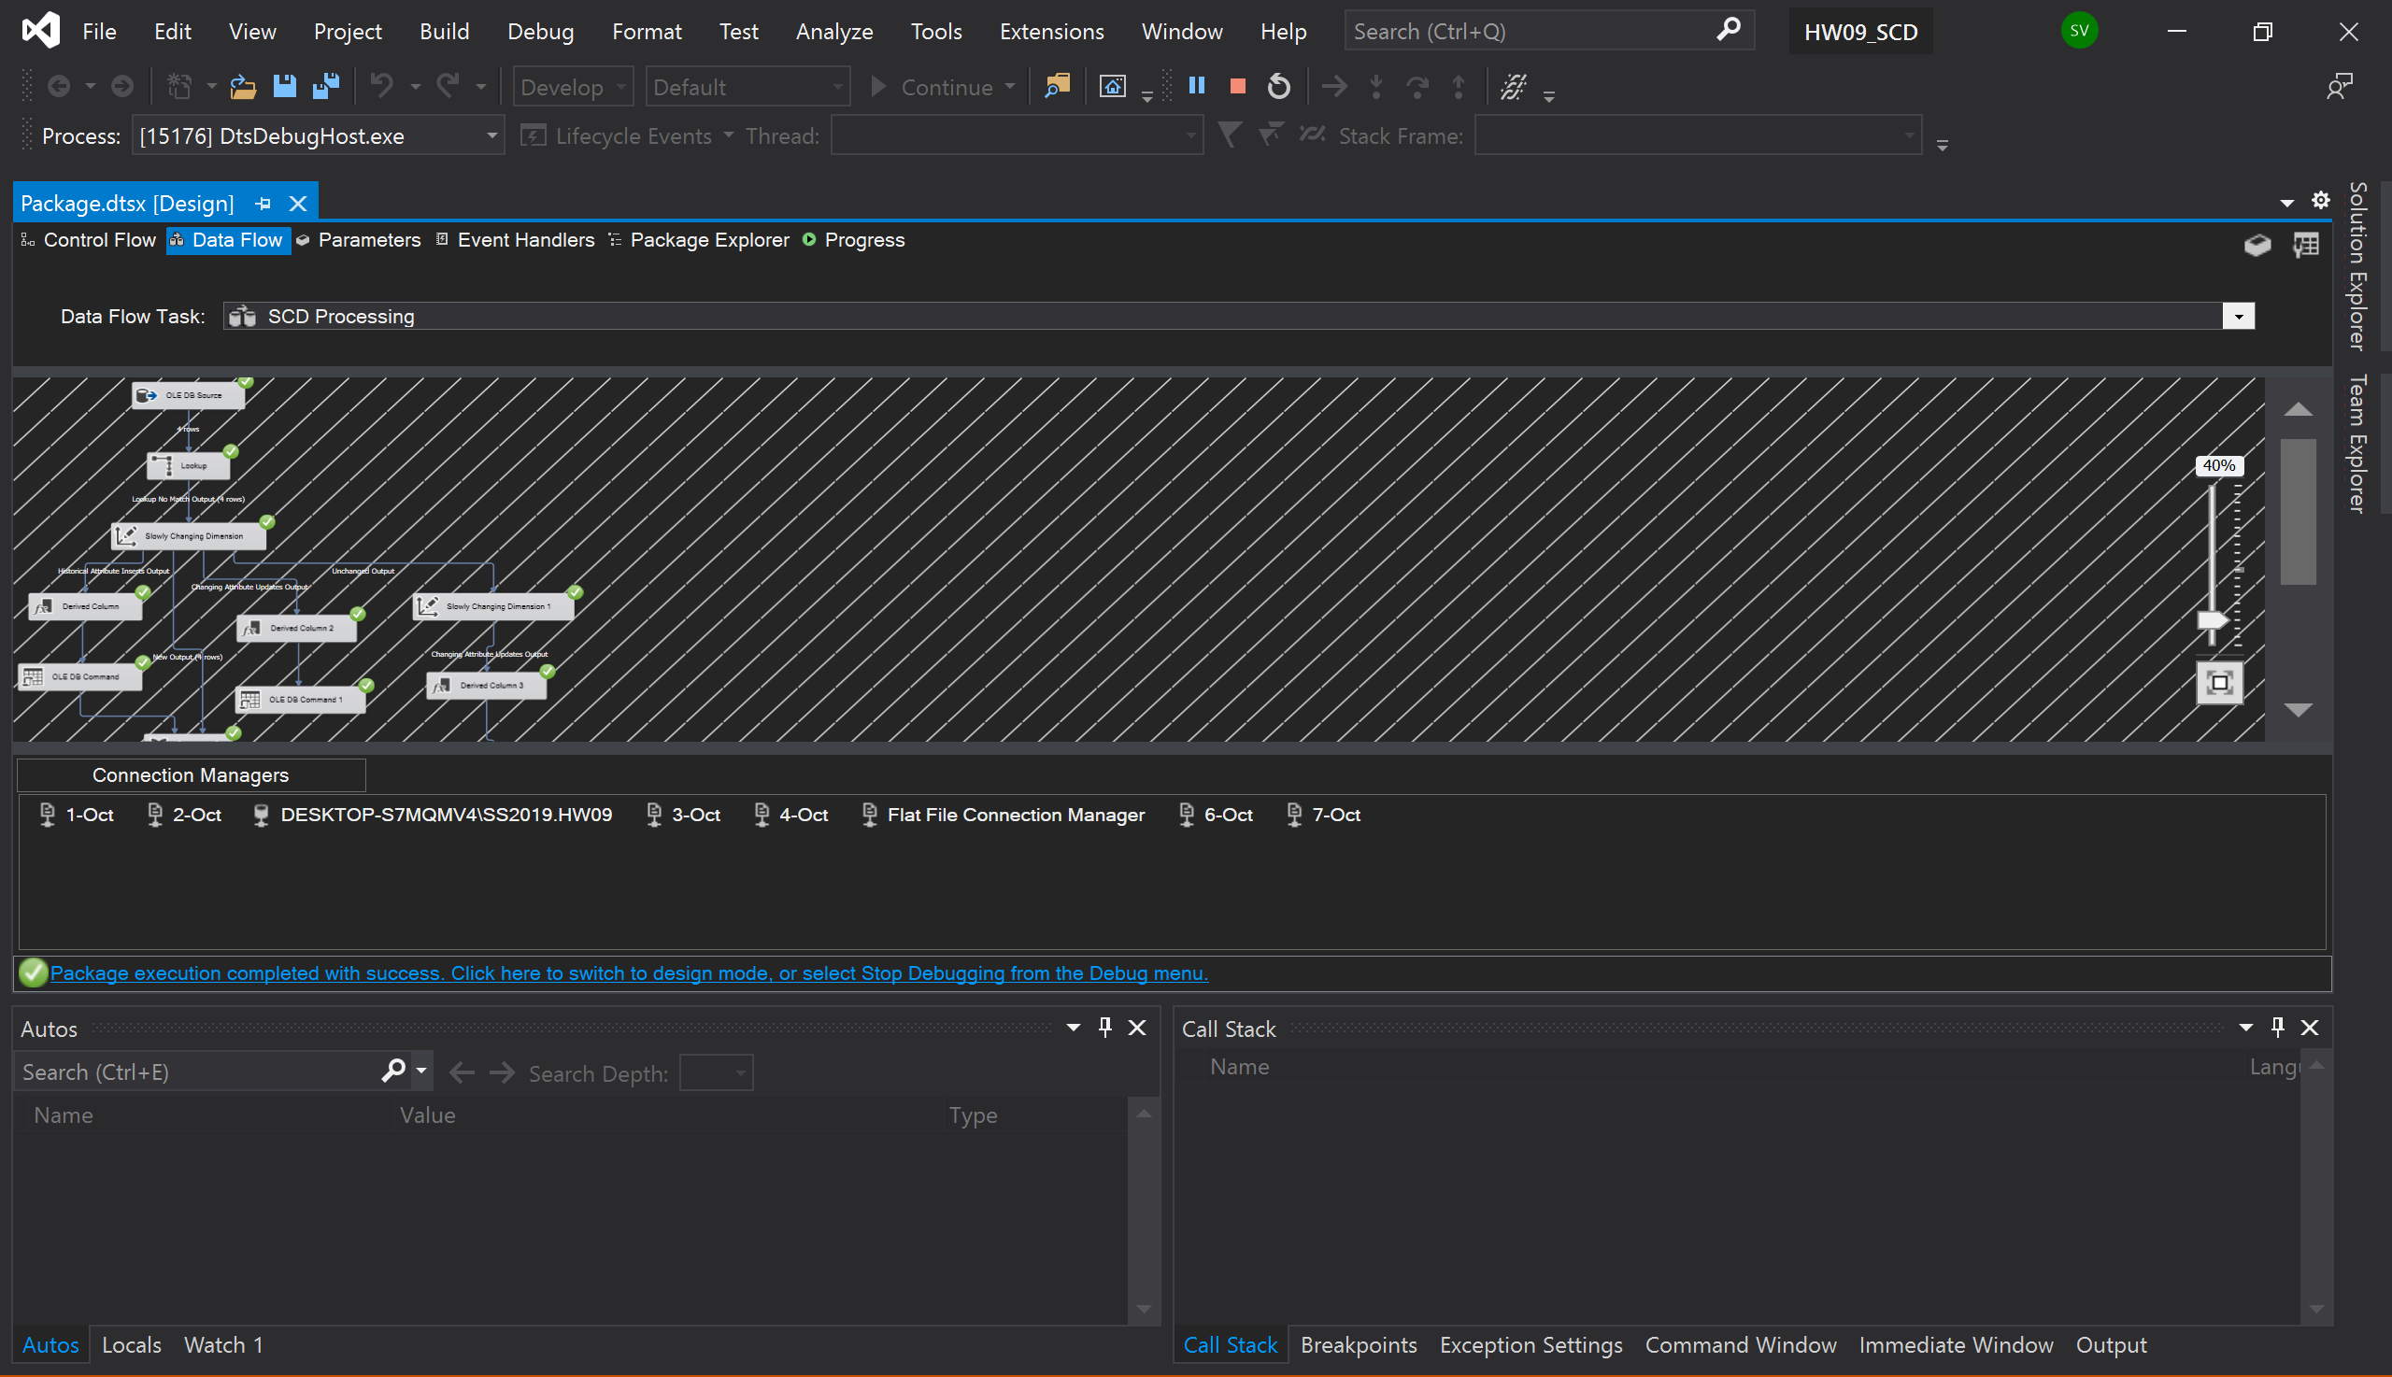

Screenshot to show data is loaded properly in destination table:

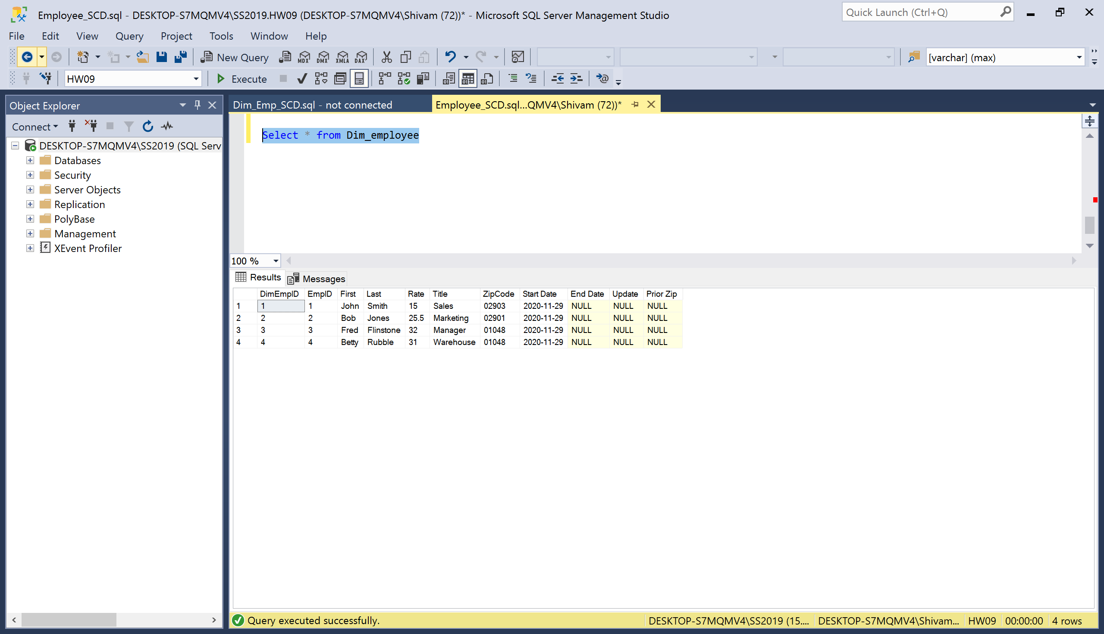

Case 1: Zip code change

Flat file:

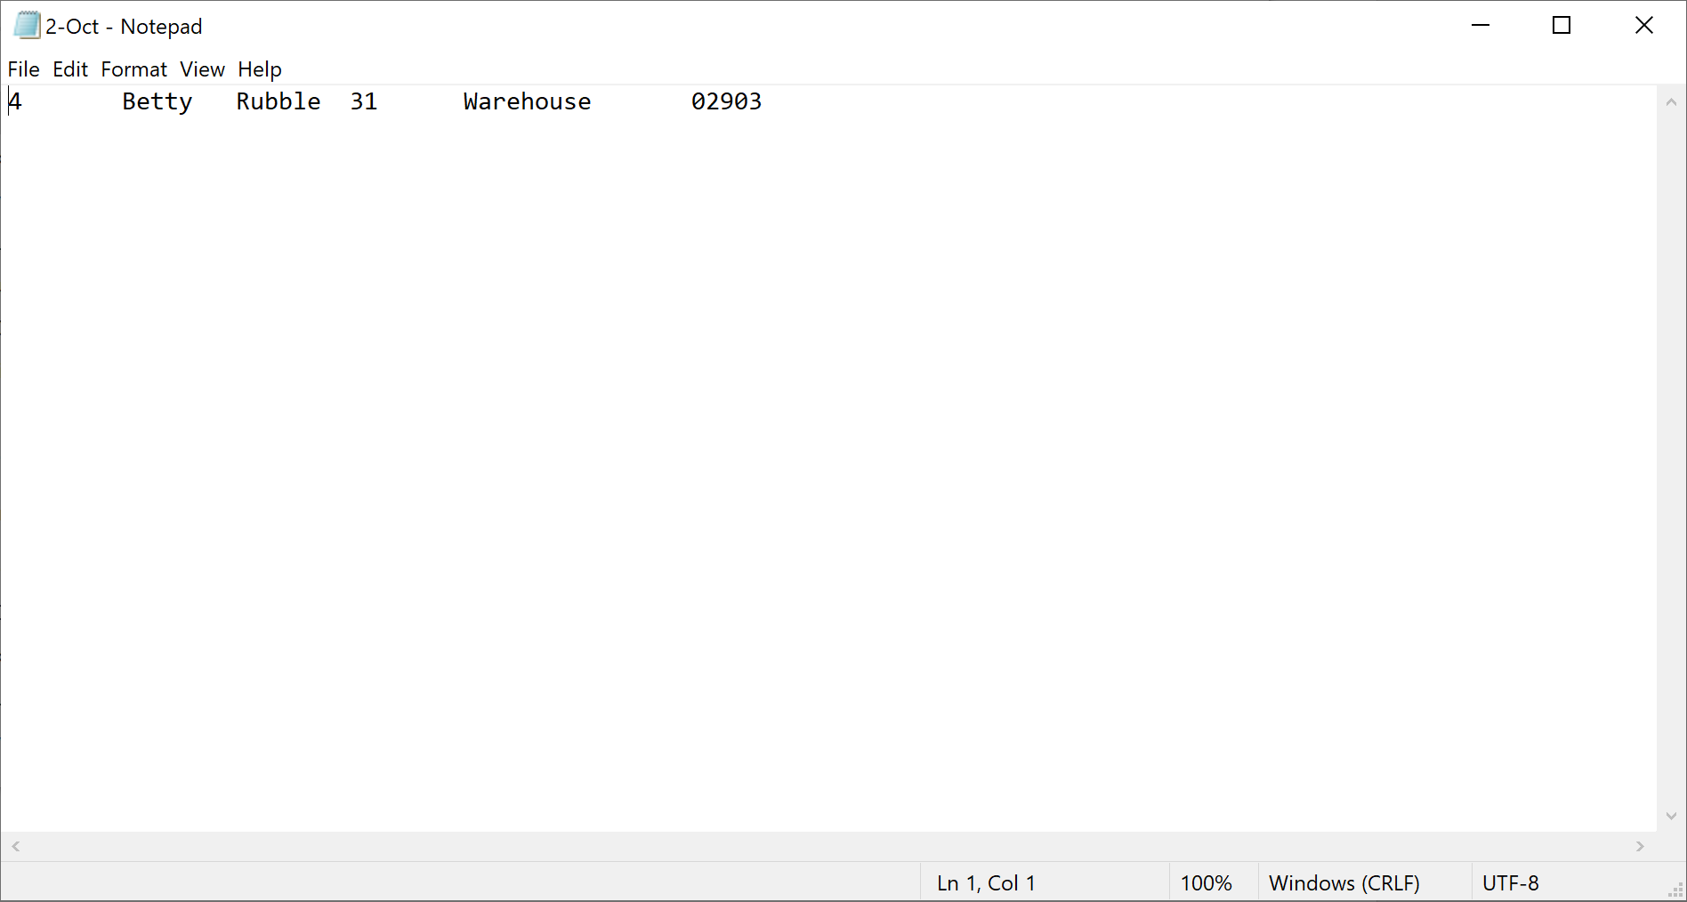

Destination table:

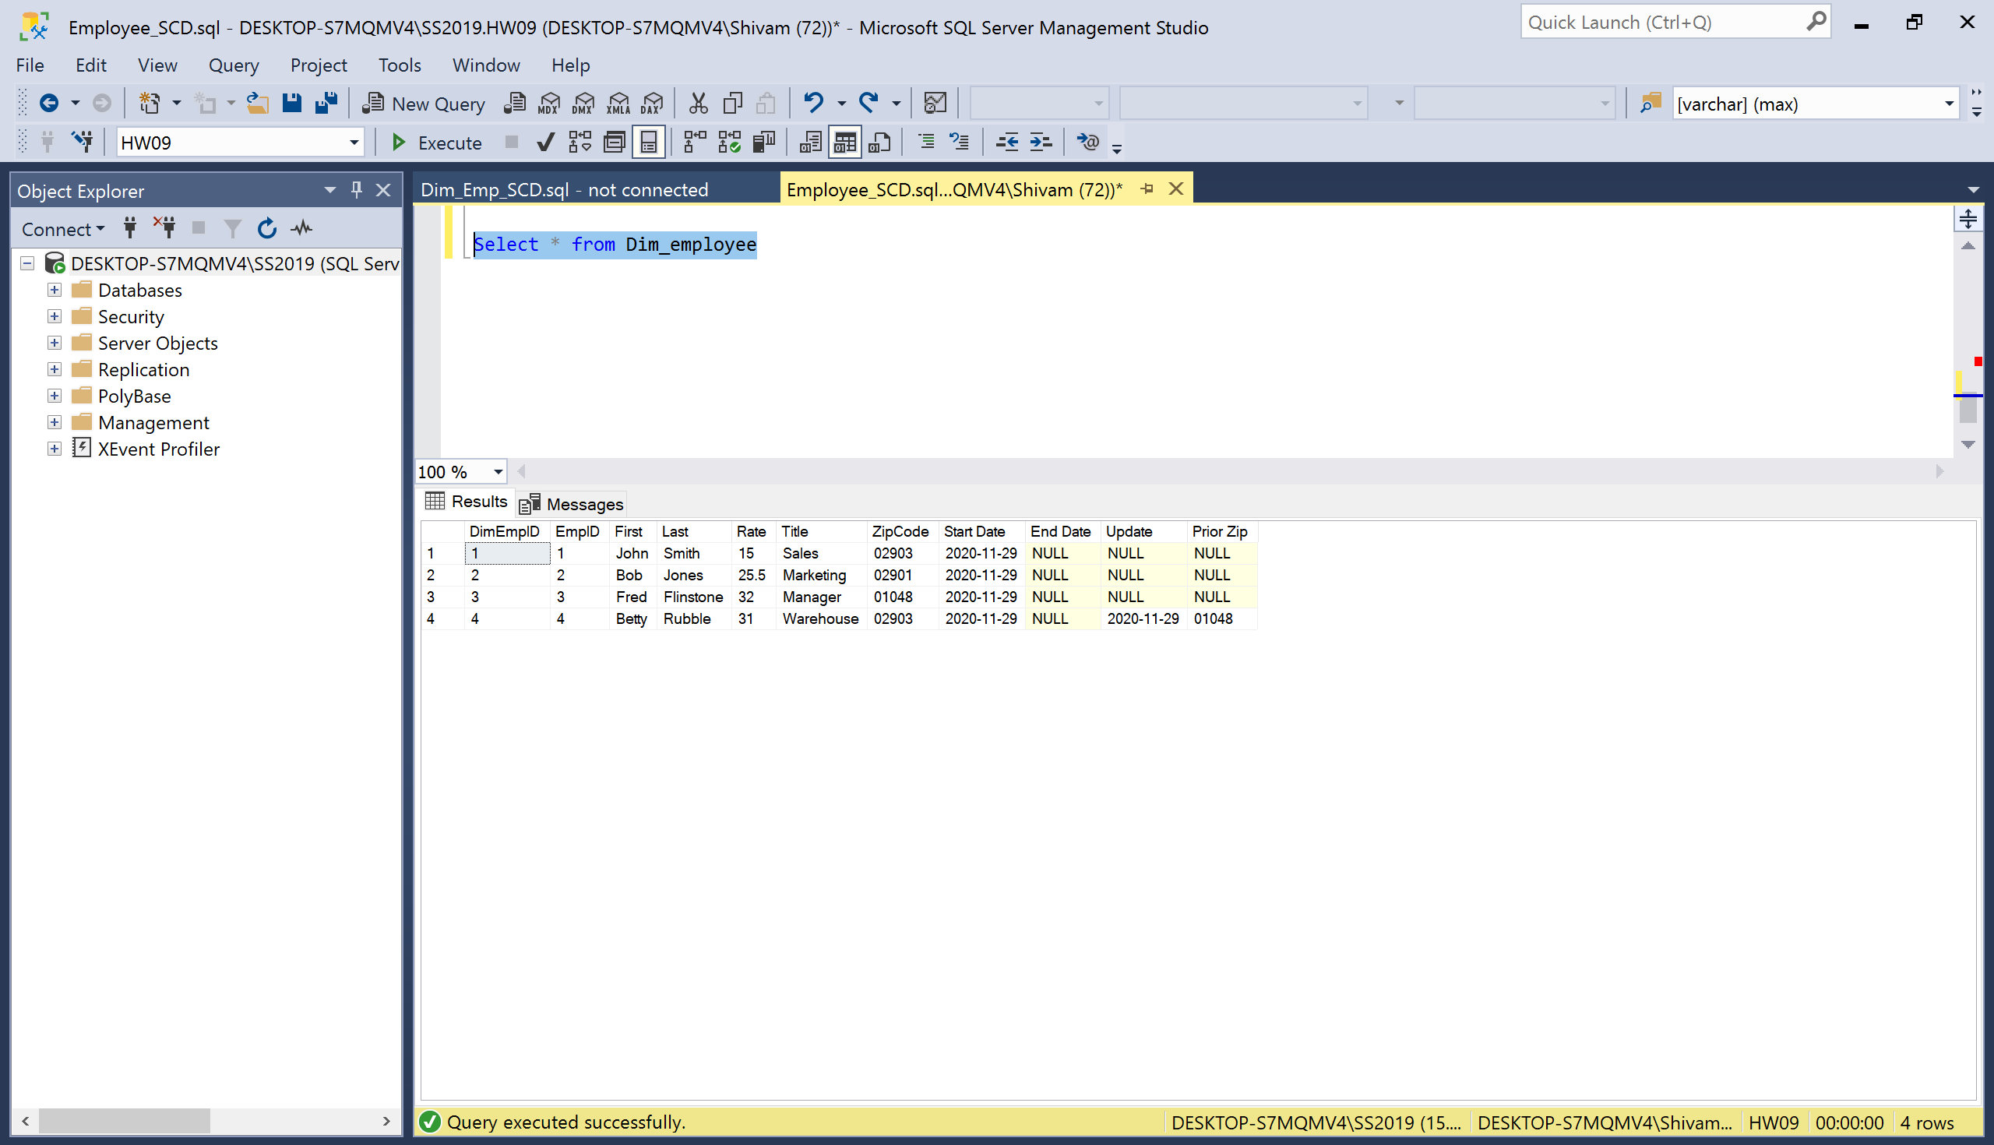

Case 2: First name change

Flat file:

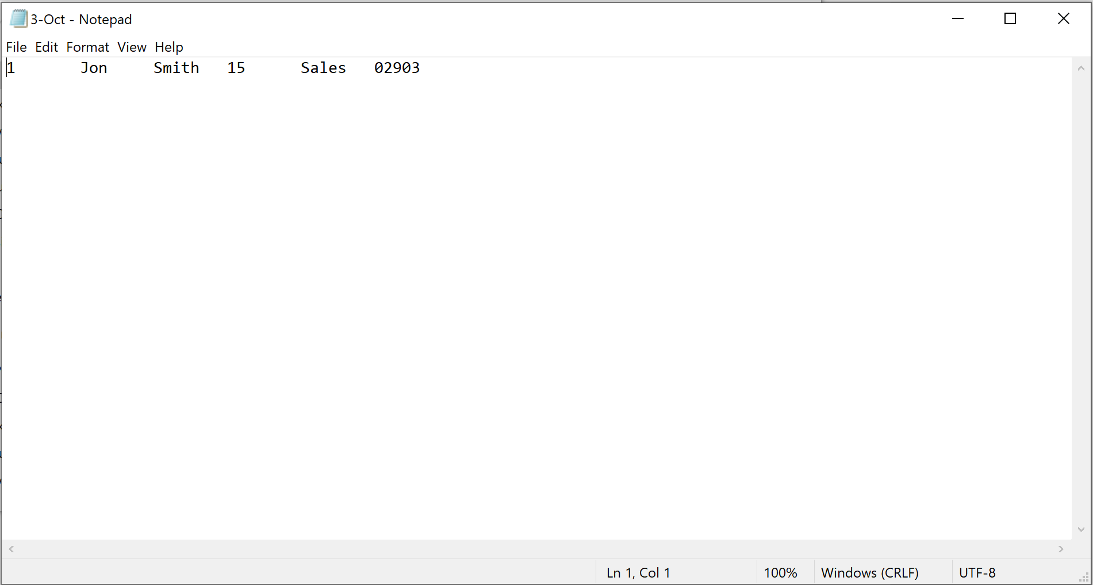

Destination table:

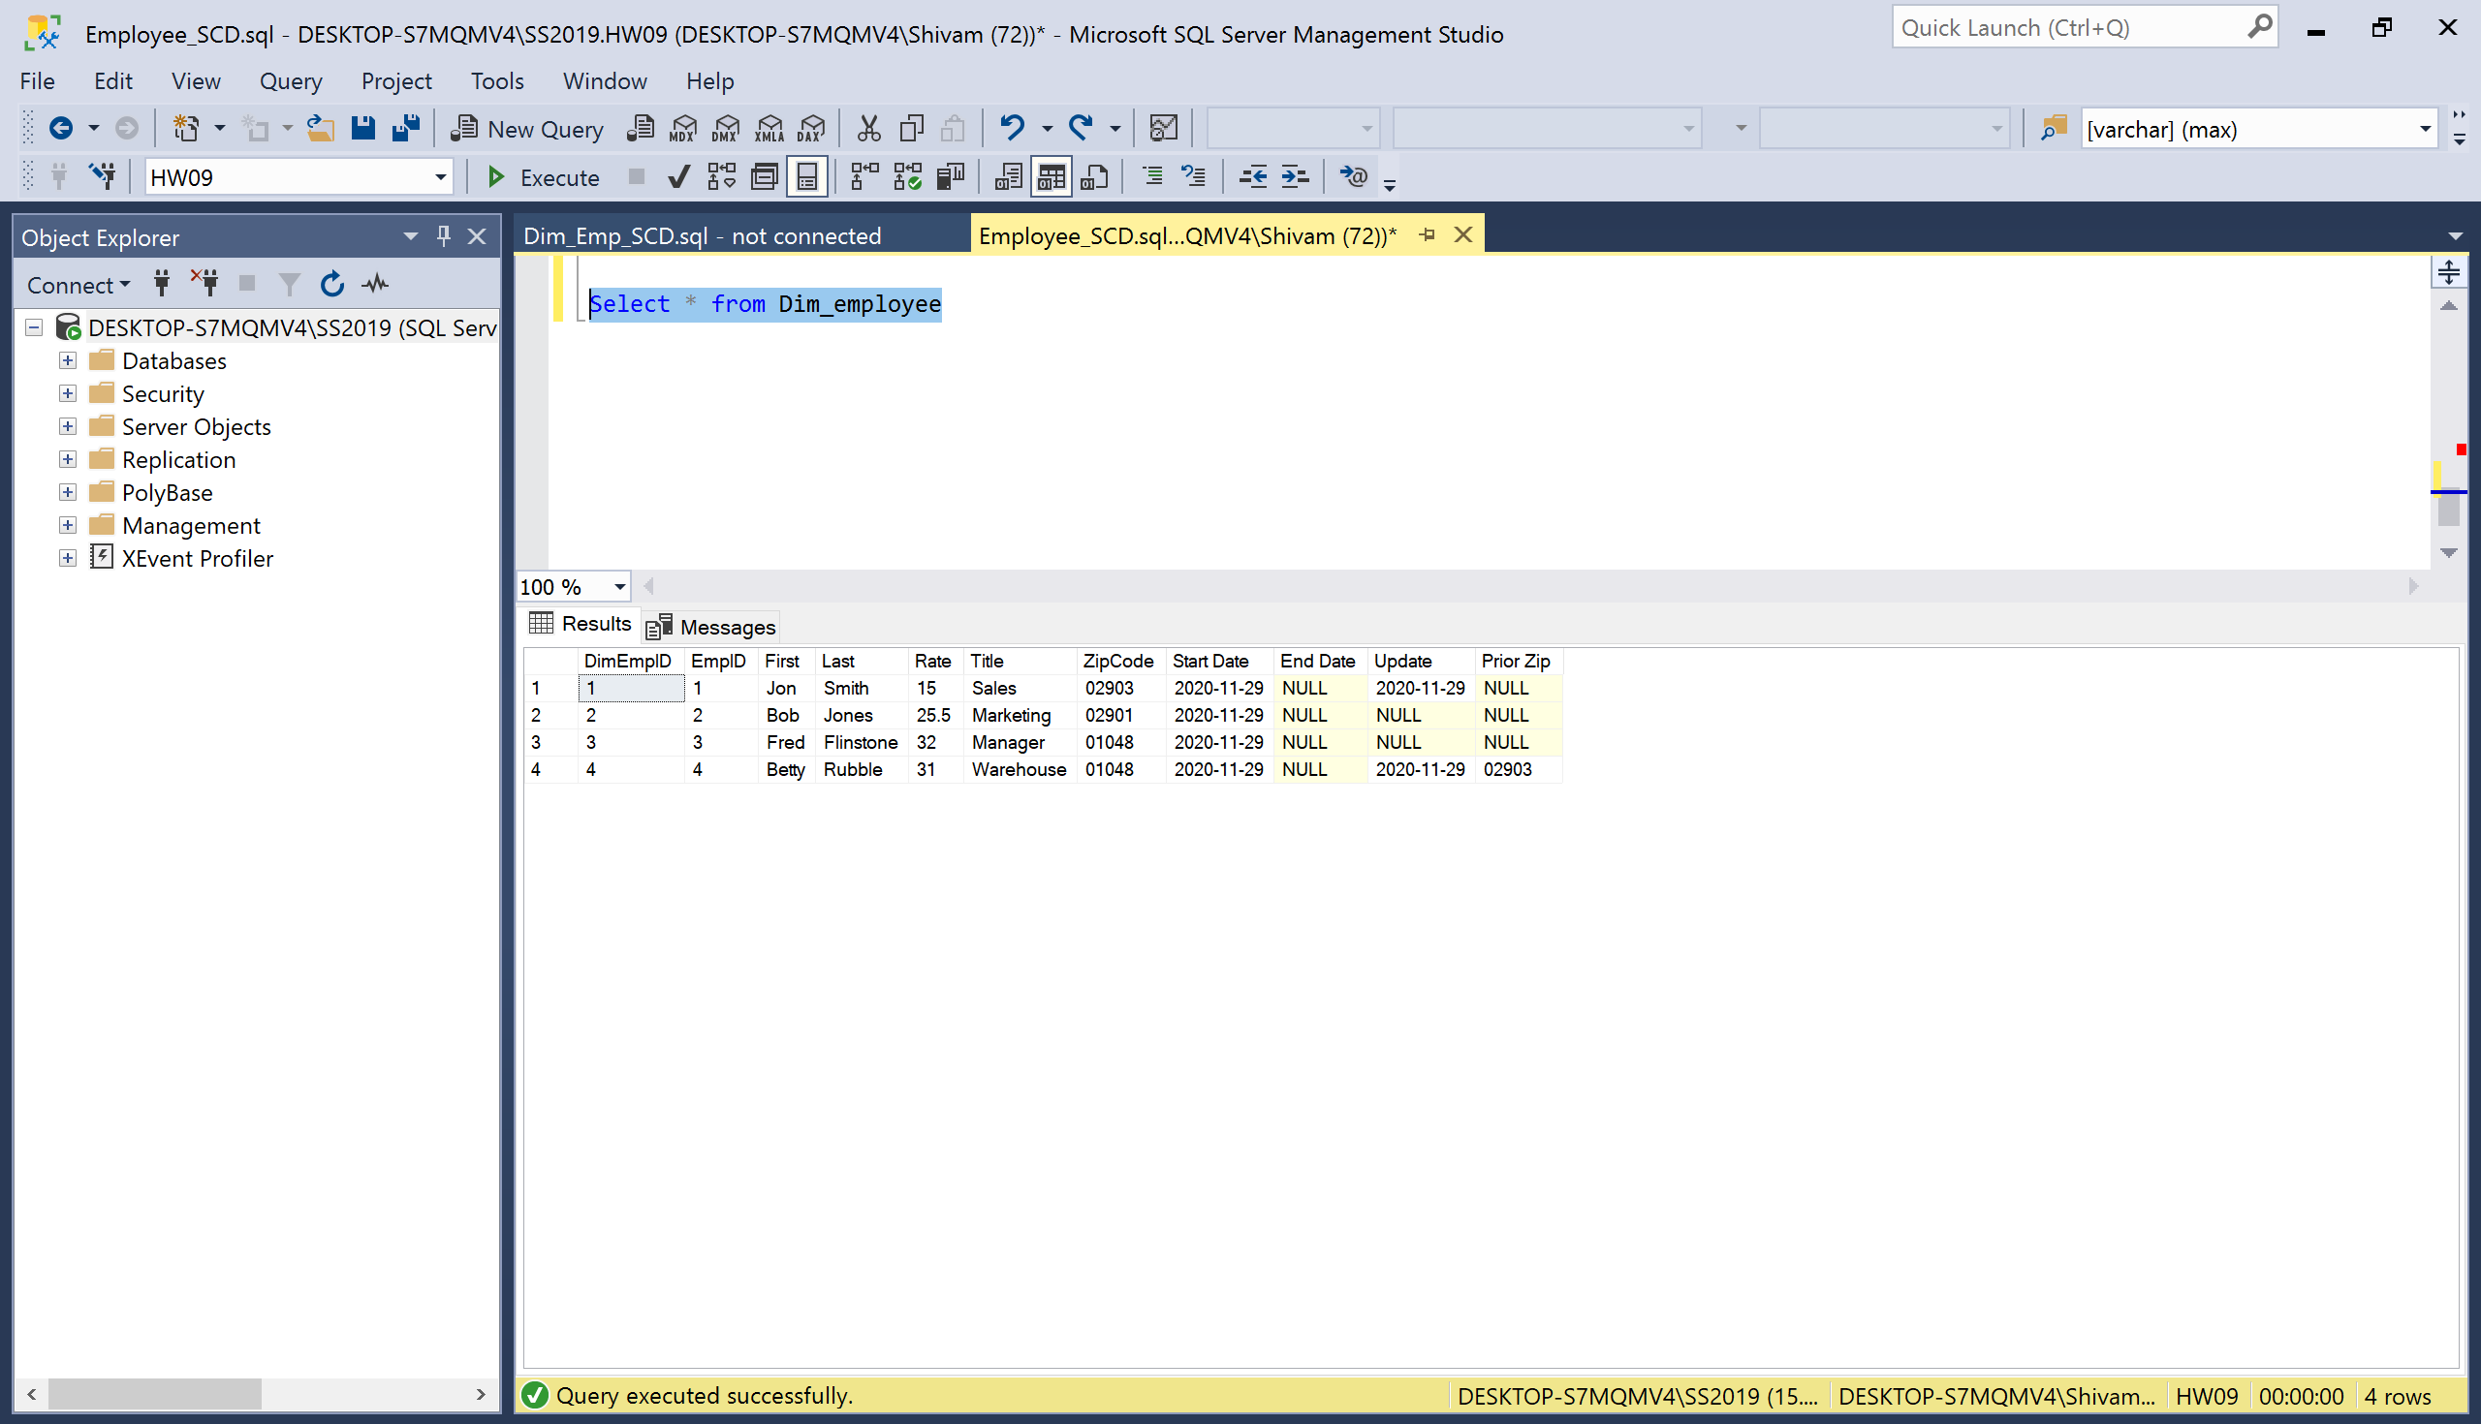

Case 3: Rate change

Flat file:

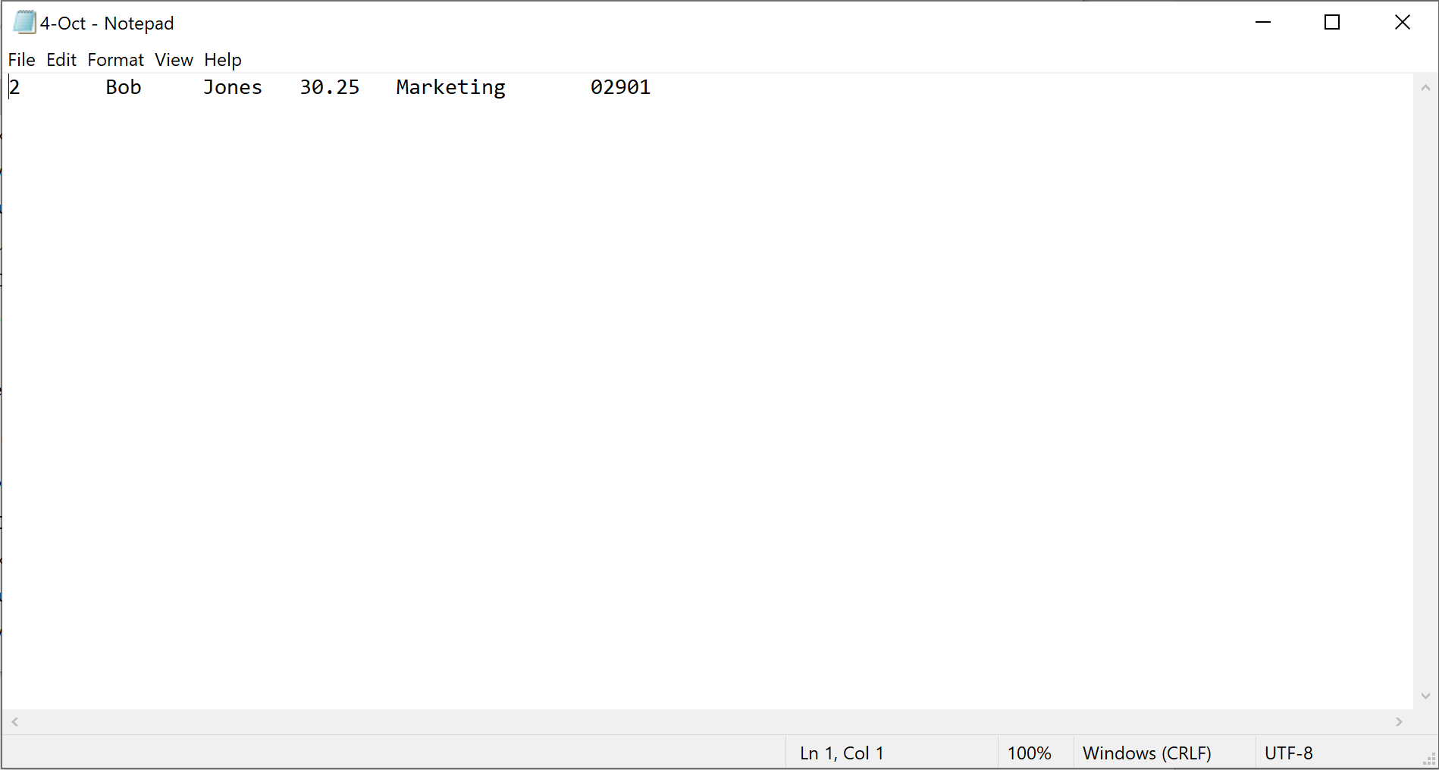

Destination table:

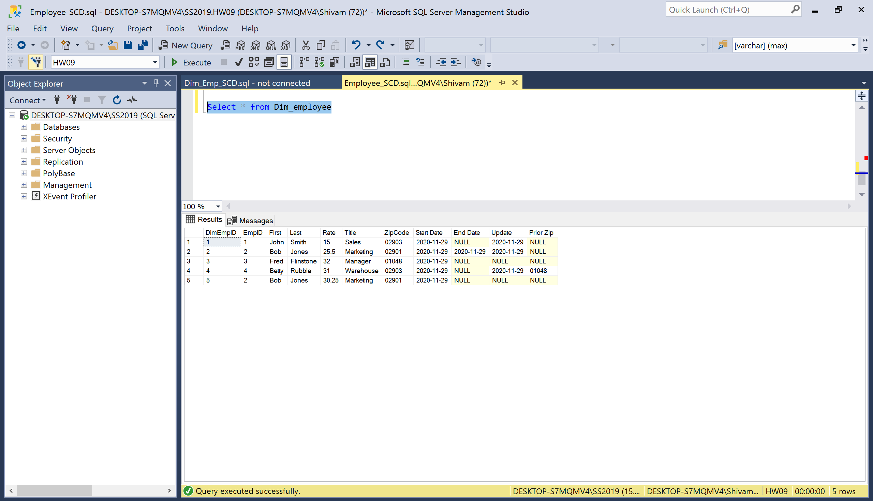

Case 4: New record

Flat file:

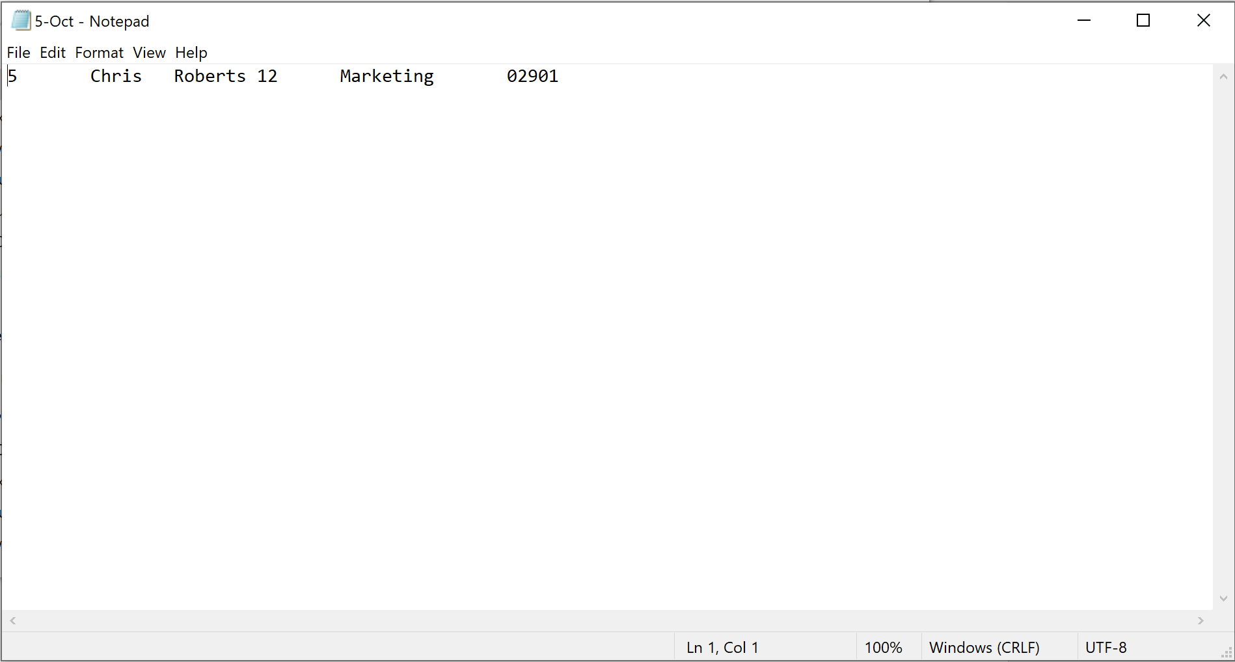

Destination table:

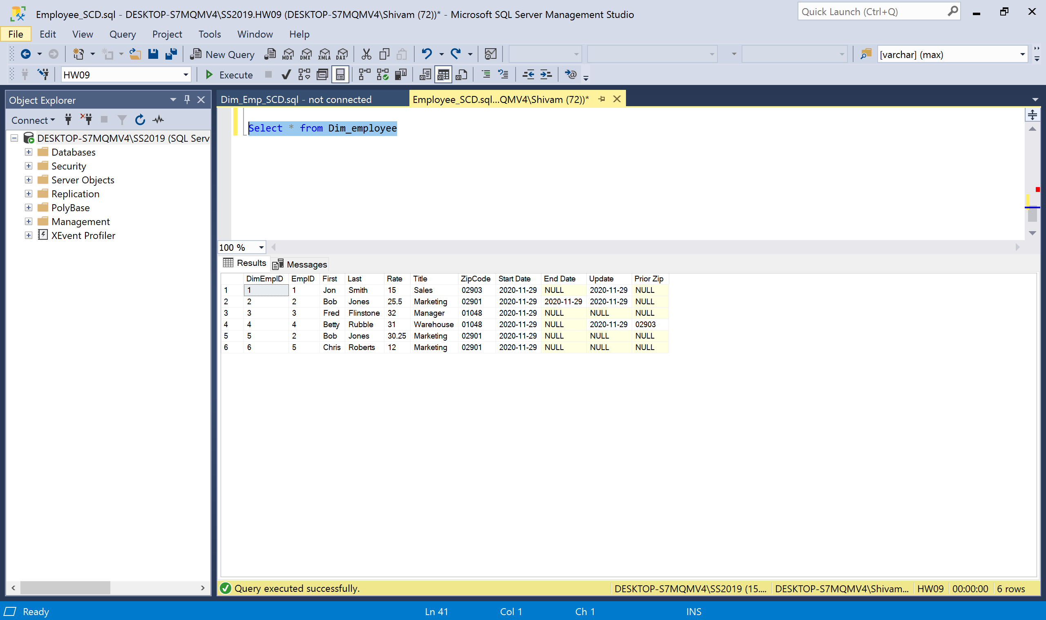

Case 5: Name update

Flat file:

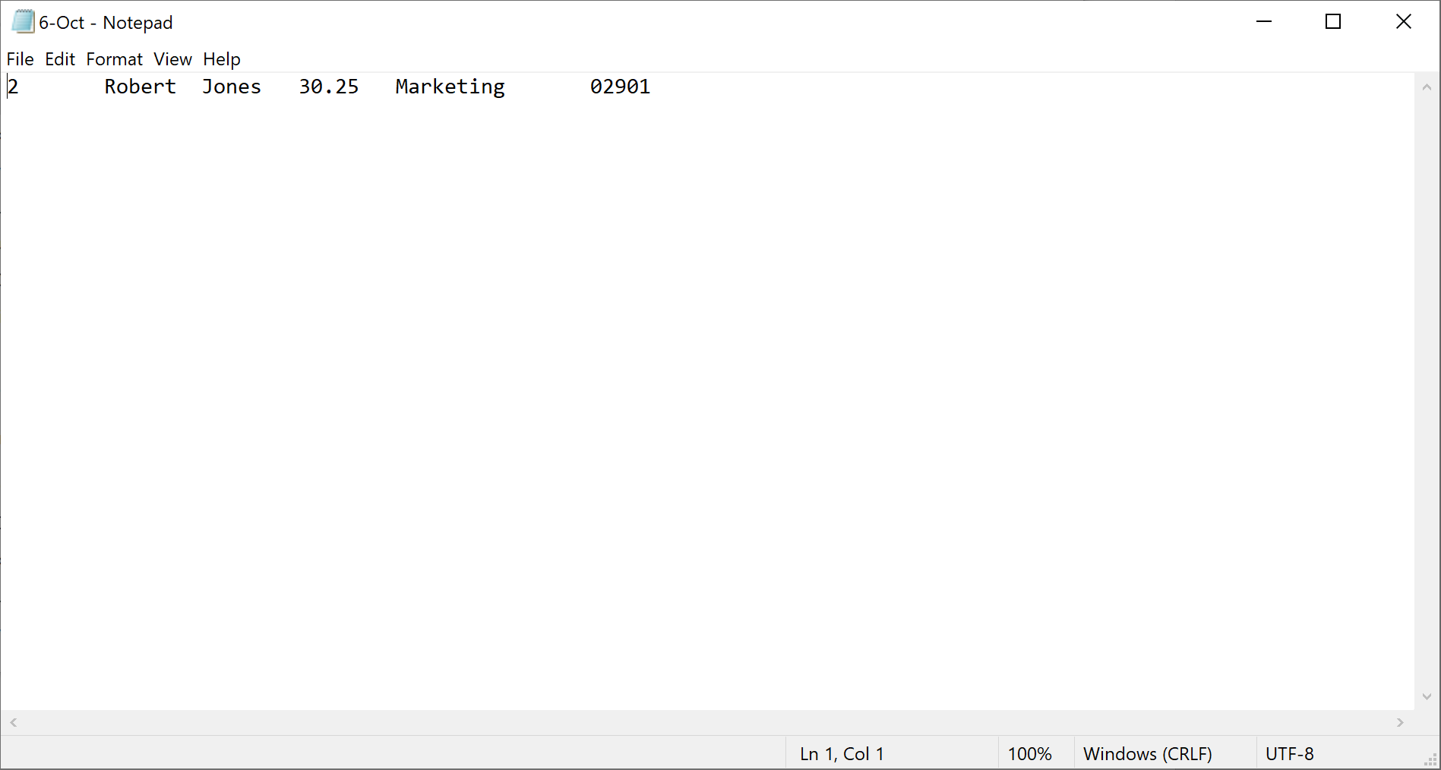

Destination table:

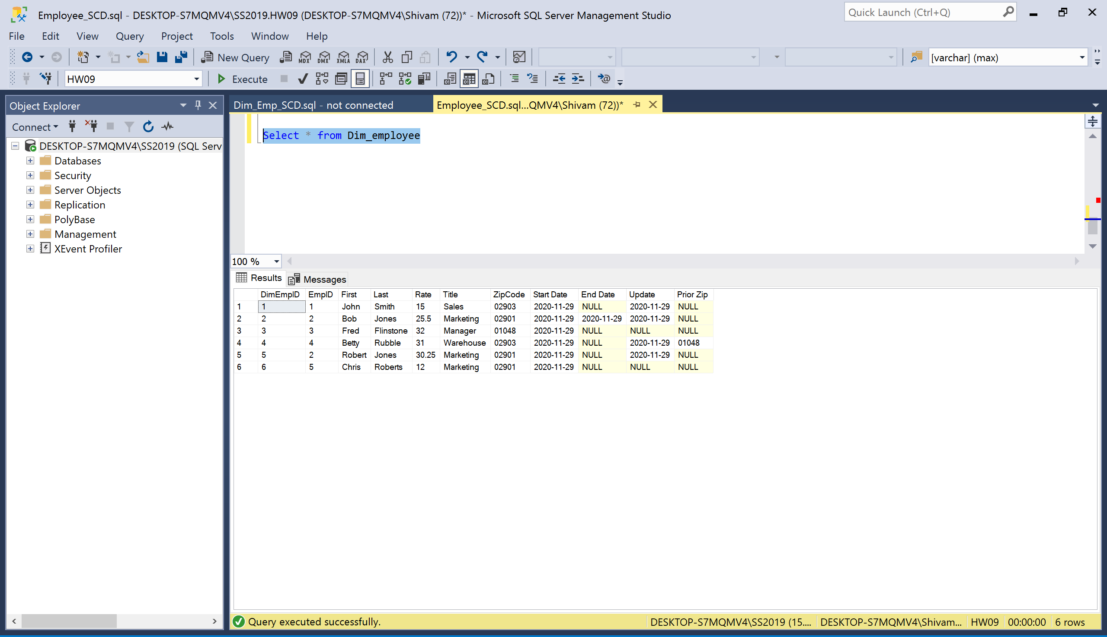

Case 6: Terminating a record

Flat File:

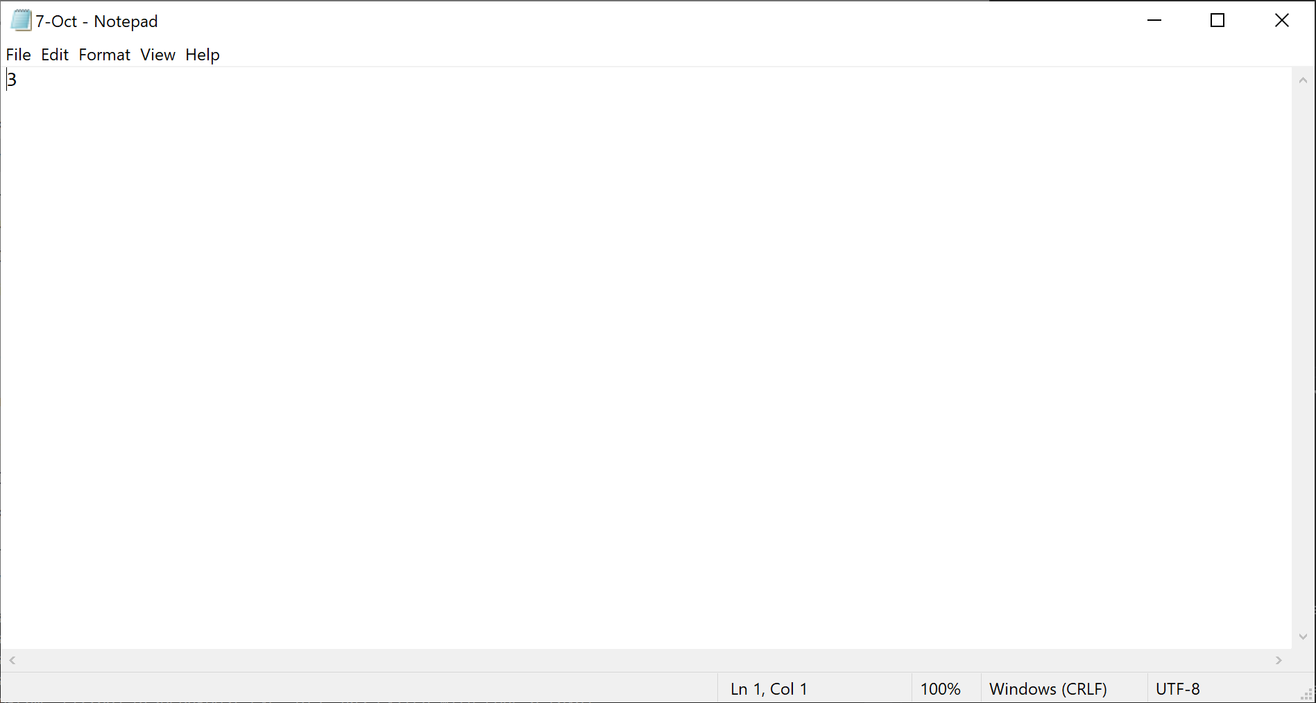

Destination table:

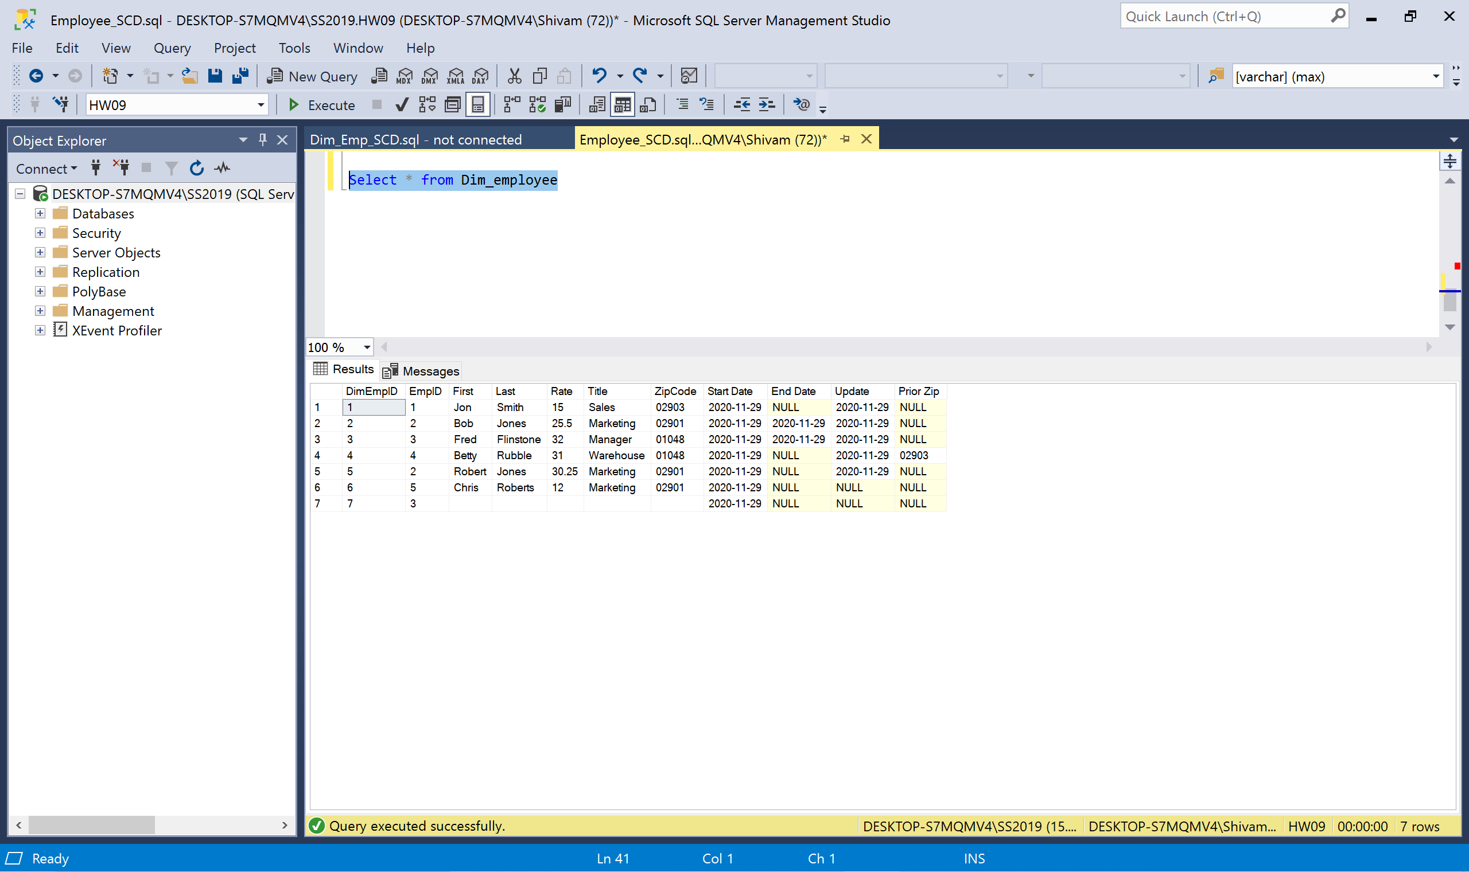

All the dates are same because it is getting system date on the same day. If package runs are done on different dates it will contain corresponding the dates.